1. 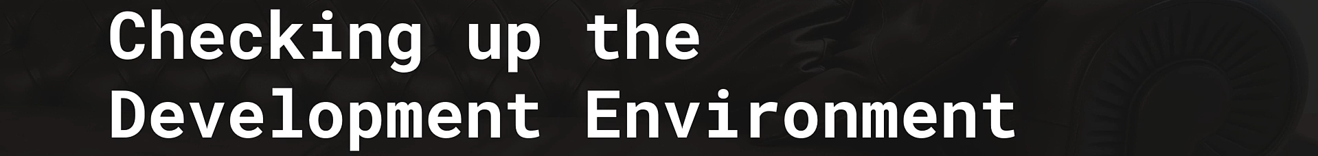
2. So, let’s first check our Development Environment.
3. **JVM**:
   1. Even though, **Quarkus is compatible with Java 8** (Even though it will not last longer), **we will be running on Java 11**.  
      **Side Note**: Quarkus is working on supporting Java 15 at the moment.
   2. For now, the **supported JVM in production** is the **OpenJDK** but it really works with other JVMs too.
4. **GraalVM**:  
   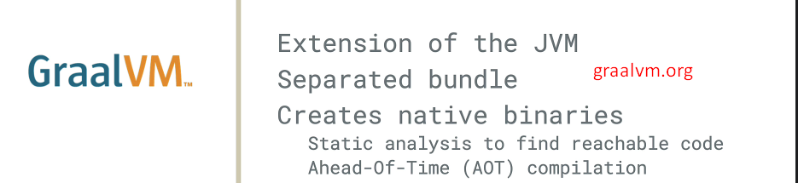
   1. **Extension** of JVM.
   2. It comes as a **separate bundle,** so we need to install it separately.
   3. Used to create Native Binary.  
      Basically, it will be used to analyze our code and then, with Ahead-Of-Time (AOT) Compilation, it will produce our **Native Image**.
   4. GraalVM.org and install.
5. IDE:
   1. A picture containing text, clipart

      Description automatically generated
   2. I will be using IntelliJ IDEA for the following reasons.
      1. Support for Mac OS X, Linux and Windows.
      2. Support for Quarkus is very good.
      3. It supports Java & Maven.
      4. Testing is very easy with Quarkus and it is nicely integrated with Intellij IDE.
      5. Community Edition is available.
6. **Building Tool**:  
   Text

   Description automatically generated with low confidence
   1. Quarkus has a Gradle Plugin and Maven Plugin & they are really in sync so have same features.
   2. I will be using Maven Plugin.
   3. There is a Quarkus maven plugin and Quarkus BOM.
   4. We will be declaring BOM in the pom.xml with version that will describe
      1. The different extensions.
      2. The Quarkus Plugins.
      3. Also a profile that will allow us to build native image very easily.
7. **Docker**:  
   Text

   Description automatically generated
   1. Quarkus has a set of extensions when it comes to Docker and also Dockerfile.
8. Graphical user interface, text, application

   Description automatically generated